Task 8

1. grep command to search the line ending with some letter?

Syntax : **grep ‘end character/letter$’ <filename>**

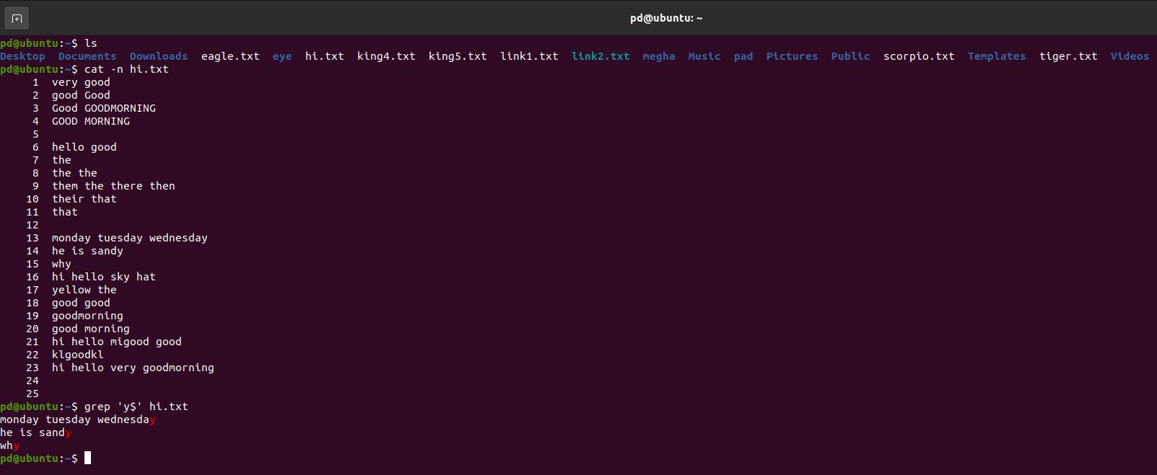

1. What is the diff between grep and sed command?

Sol :

|  |  |
| --- | --- |
| **grep** | **sed** |
| Searches for patterns in files. | Edits or modifies the content of files. |
| Displays lines that match a pattern. | Can display, delete, or modify lines based on patterns. |
| Used for searching text or patterns. | Used for searching, replacing, and editing text. |
| Prints matching lines. | Modifies and can print or save the edited content. |
| Cannot modify files, only shows results. | Can modify files (in-place or print changes). |
| Simple to use for finding text patterns. | More complex due to its editing capabilities. |
| grep "pattern" file.txt | sed 's/old/new/' file.txt |